TASK | Cleaning/washing agents and additives
LOCATION OF USE | Workshop and field engineers |  | Assessment  No |  | 035
PRODUCT NAME | DD10
DESCRIPTION OF SUBSTANCE | Blue liquid, Almost odourless
MANUFACTURER | Clover Chemicals Ltd  Clover House  Macclesfield Road  SK23 7DQ  Whaley Bridge  Derbyshire  United Kingdom
MANUFACTURERS CONTACT | T 01663 733114
ASSESSOR | Martin Monaghan CMIOSH |  | Date |  | 04 12 25
TITLE | Health and Safety Consultant |  | Review by |  | 04 12 27
Personnel Performing Task  (Please list below)  Technicians/ Fitters/ Workshop Operatives |  | Time Spent  (Minutes/day)  As and when required, amounting to a few minutes per day | Training Given 
 |  |  | Yes

MSDS Revision Date | Hazard Statement
15/02/23 | H318: Causes severe skin burns and eye damage

Assessment to be conducted in Association with Hazard Data Sheets, a full current copy of which must be attached to this assessment.

Please denote the hazardous properties of the substances used in the task with a 

NEW INTERNATIONAL GLOBALLY HARMONISED HAZARD SYMBOLS
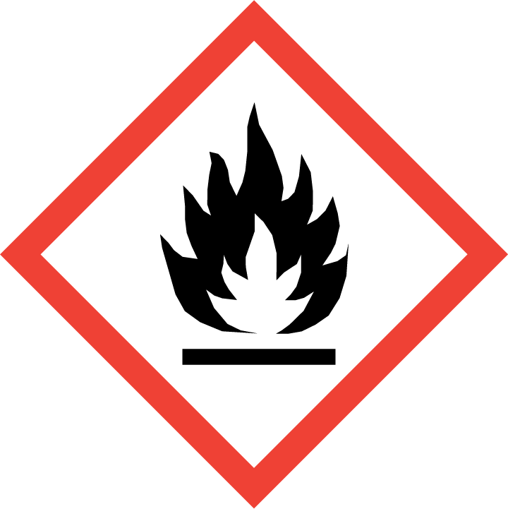 | 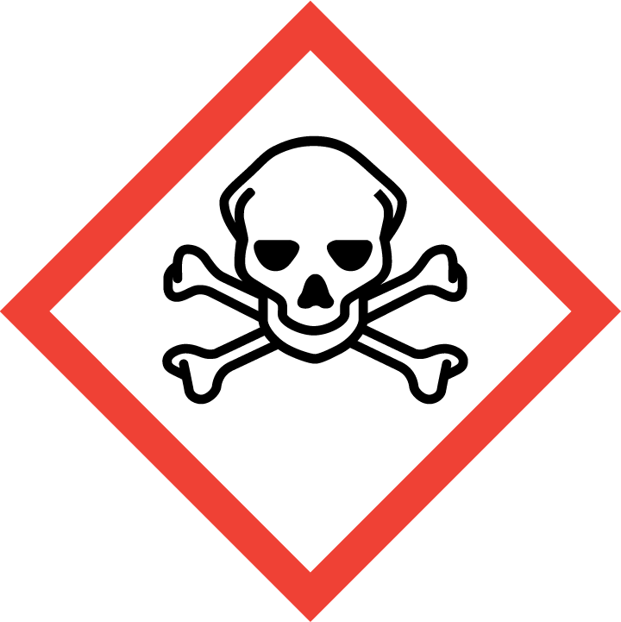 | 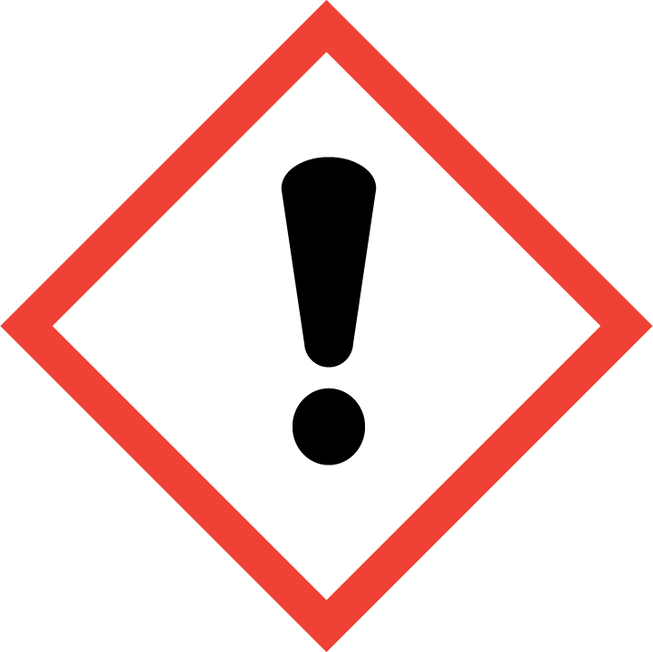 | 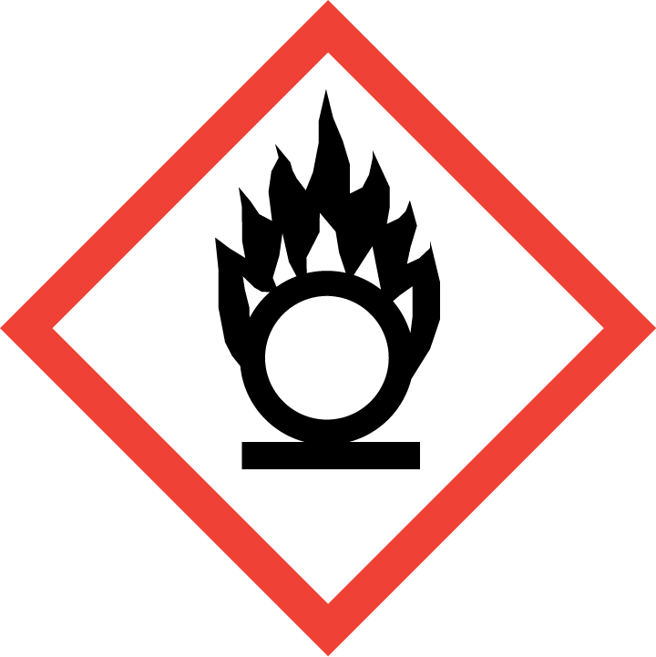 | 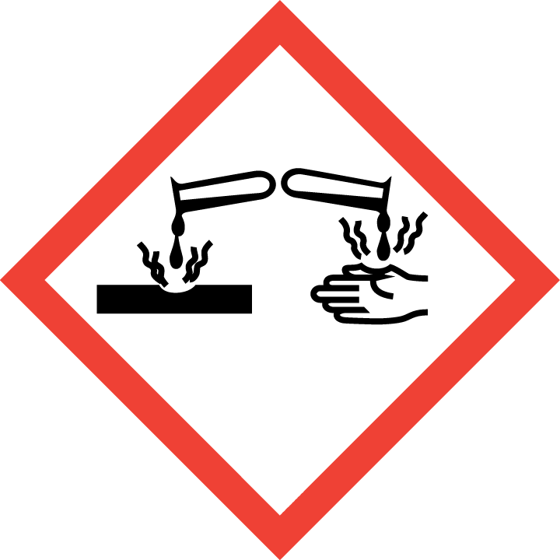 | 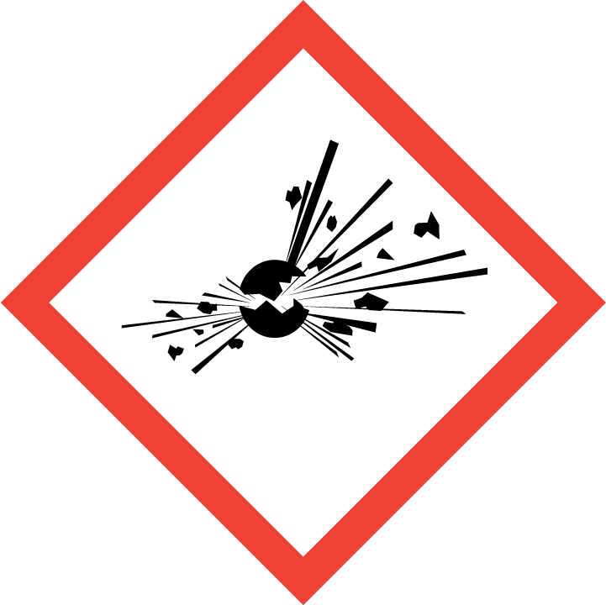 | 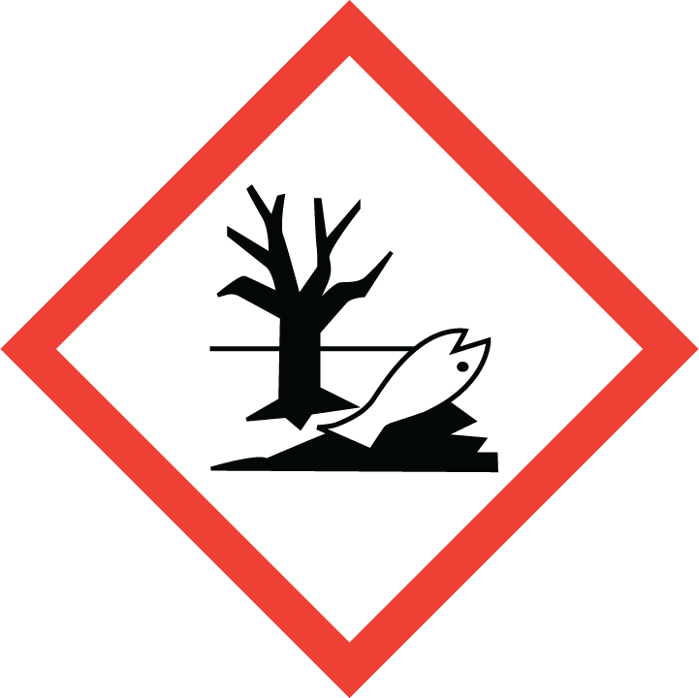 | 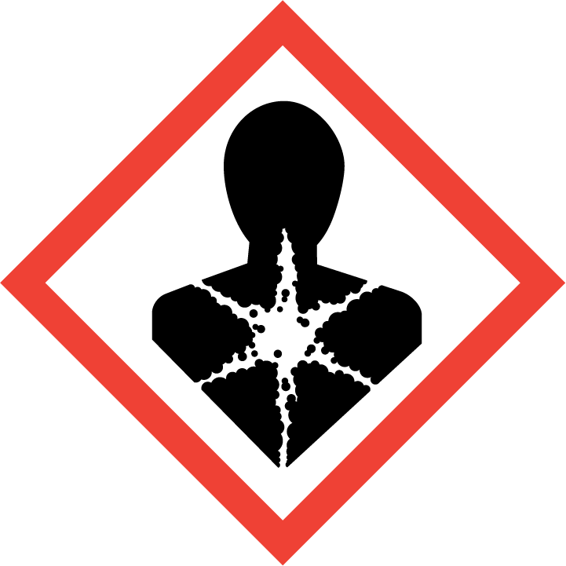
Flammable | Toxic | Harmful | Oxidising | Corrosive | Explosive | Harmful to the environment | Health Hazards i.e. respiratory sensitisation or carcinogenicity
 |  |  |  | 

SMOKING, EATING AND DRINKING ARE PROHIBITED IN THE WORK AREAS.
Information, Instruction and Training must be provided to all users. Young Persons, New or Expectant Mothers and other vulnerable groups must not use or be exposed to this product.

WORKPLACE EXPOSURE LIMITS (WEL’s)
IMPORTANT!
Refer to Workplace Exposure Levels information provided in the Manufacturers Safety Data and revise control measures if exposure levels likely to be reached.

ROUTE OF EXPOSURE
Skin |  | Eyes |  | Inhalation | 
Ingestion |  | Cuts/abrasions |  | Systemic

PERSONS AT RISK
User of product |  | Co workers |  | Members of the public

ROUTE OF EXPOSURE | 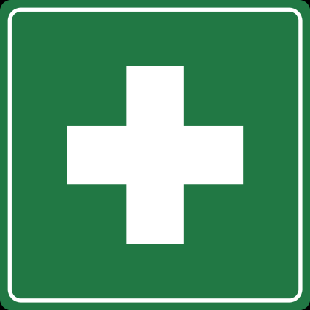  FIRST AID MEASURES
Inhalation | Allow affected person to breathe fresh air. Allow the victim to rest
Skin contact | Remove affected clothing and wash all exposed skin area with mild soap and water, followed by warm water rinse.
Eye contact | Rinse cautiously with water for several minutes. Remove contact lenses, if present and easy to do. Continue rinsing. Immediately call a POISON CENTER/doctor
Swallowing | Rinse mouth. Do NOT induce vomiting. Obtain emergency medical attention.
In all cases of doubt, or if symptoms persist seek medical attention. Never give anything by mouth to an unconscious person. If unconscious, place in recovery position and seek medical advice.

PERSONAL PROTECTIVE EQUIPMENT
 |  | 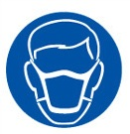 |  | 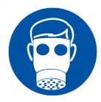 | 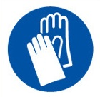 | 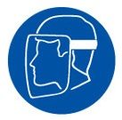
YES | YES | YES/NO |  | YES/NO | YES | YES/NO
 |  |  |  |  | 
YES –goggles or safety glasses | YES |  |  |  | YES – Rubber gloves

HANDLING | STORAGE | TRANSPORT | DISPOSAL
Wash hands and other exposed areas with mild soap and water before eating, drinking or smoking and when leaving work. Provide good ventilation in process area to prevent formation of vapour. | Store in a cool, well-ventilated place |  | Must not be disposed of with household waste. Used, degraded or contaminated product may be classified as hazardous waste. Return empty aerosols to the factory for disposal.

REQUIRED CONTROL MEASURES
- Ensure only minimum amounts are stored on site.
- Ensure approved rubber gloves are used at all times.
- Ensure appropriate eye protection is worn.
- Ensure overalls are worn and these are suitably laundered.
- Ensure that work is undertaken in well ventilated areas.
- Ensure that Engineers are equipped with antibacterial hand washes and wipes and that good hygiene practices are enforced.
- Wash hands thoroughly after handling.

FIRE PRECAUTIONS
Use water spray or fog for cooling exposed containers. Exercise caution when fighting any chemical fire. Prevent fire fighting water from entering the environment.

ACCIDENTAL RELEASE/SPILLAGE PROCEDURES
Avoid any contact with the skin and eyes. If a large quantity has been spilt, evacuate all personnel and only allow intervention by trained operators equipped with safety apparatus.

MONITORING REQUIREMENTS AND HEALTH SURVEILLANCE
Health surveillance is not in place for workers exposed to this product.

